**PIZZA SALES SQL QUERIES**

1. **KPI’s:-**
2. **Total Revenue:**

SELECT SUM(total_price) AS Total_Revenue FROM pizza_sales;

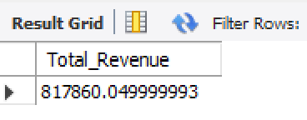

1. **Total Orders:**

SELECT COUNT(DISTINCT order_id) AS Total_Orders FROM pizza_sales;

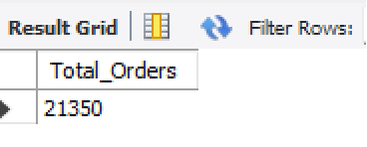

1. **Average Order Value:**

SELECT (SUM(total_price) / COUNT(DISTINCT order_id)) AS Avg_order_Value FROM pizza_sales;

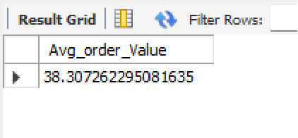

1. **Total Pizzas Sold:**

SELECT SUM(quantity) AS Total_pizza_sold FROM pizza_sales;

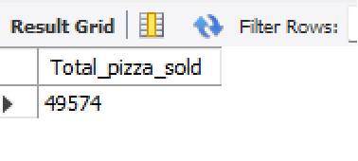

1. **Average Pizzas Per Order:**

SELECT CAST(CAST(SUM(quantity) AS DECIMAL(10,3)) /

CAST(COUNT(DISTINCT order_id) AS DECIMAL(10,3)) AS DECIMAL(10,3)) AS Avg_Pizzas_per_order FROM pizza_sales;

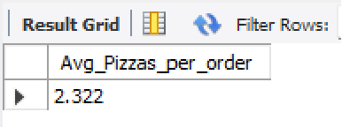

1. **Daily Trend for Total Orders:**

SELECT DAYNAME(STR_TO_DATE(order_date, '%Y-%m-%d')) AS order_day,

COUNT(DISTINCT order_id) AS total_orders

FROM pizza_sales

GROUP BY DAYNAME(STR_TO_DATE(order_date, '%Y-%m-%d'))

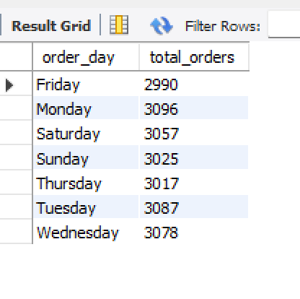

1. **Monthly Trend for Orders:**

SELECT MONTHNAME(STR_TO_DATE(order_date, '%Y-%m-%d')) AS order_day,

COUNT(DISTINCT order_id) AS total_orders

FROM pizza_sales

GROUP BY MONTHNAME(STR_TO_DATE(order_date, '%Y-%m-%d'))

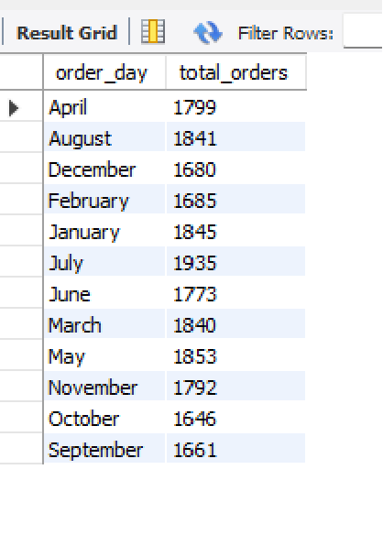

1. **% of Sales by Pizza Category:**

SELECT pizza_category, CAST(SUM(total_price) AS DECIMAL(10,3)) AS total_revenue,

CAST(SUM(total_price) * 100 / (SELECT SUM(total_price) from pizza_sales) AS DECIMAL(10,3)) AS PCT

FROM pizza_sales

GROUP BY pizza_category

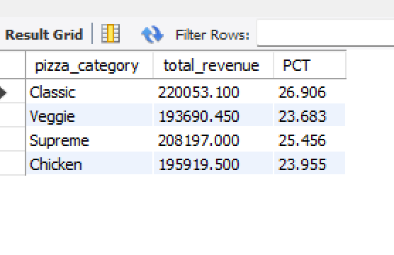

1. **% of Sales by Pizza Size:**

SELECT pizza_size, CAST(SUM(total_price) AS DECIMAL(10,3)) AS total_revenue,

CAST(SUM(total_price) * 100 / (SELECT SUM(total_price) FROM pizza_sales) AS DECIMAL(10,3)) AS PCT

FROM pizza_sales

GROUP BY pizza_size

ORDER BY pizza_size

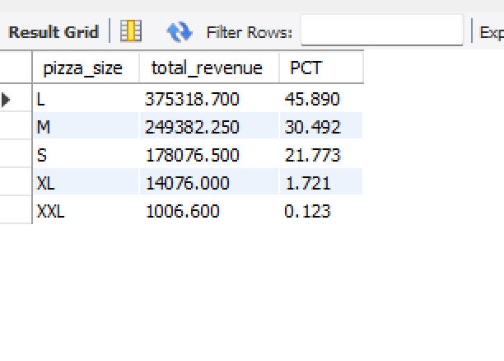

1. **Total Pizzas Sold by Pizza Category:**

SELECT pizza_category, SUM(quantity) AS Total_Quantity_Sold

FROM pizza_sales

GROUP BY pizza_category

ORDER BY Total_Quantity_Sold DESC

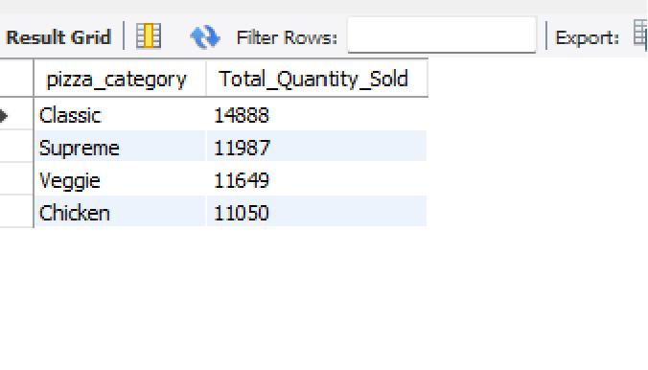

1. **Top 5 Pizzas by Revenue:**

SELECT pizza_name, SUM(total_price) AS Total_Revenue

FROM pizza_sales

GROUP BY pizza_name

ORDER BY Total_Revenue DESC

LIMIT 5;

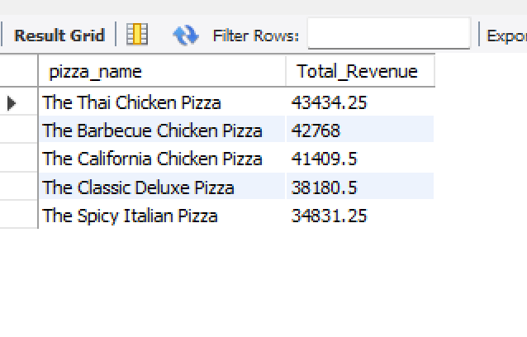

1. **Bottom 5 Pizzas by Revenue:**

SELECT pizza_name, SUM(total_price) AS Total_Revenue

FROM pizza_sales

GROUP BY pizza_name

ORDER BY Total_Revenue ASC

LIMIT 5;

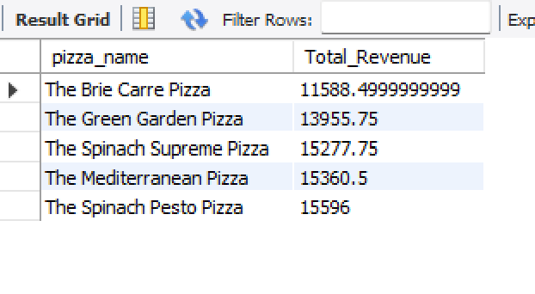

1. **Top 5 Pizzas by Quantity:**

SELECT pizza_name, SUM(quantity) AS Total_Pizza_Sold

FROM pizza_sales

GROUP BY pizza_name

ORDER BY Total_Pizza_Sold DESC

LIMIT 5;

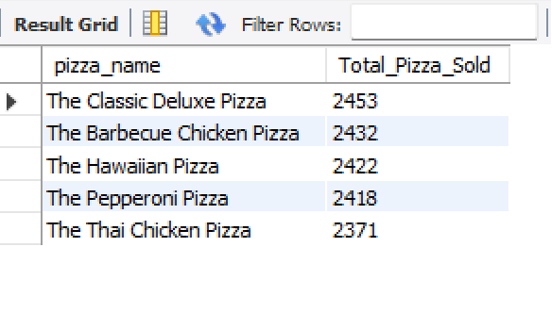

1. **Bottom 5 Pizzas by Quantity:**

SELECT pizza_name, SUM(quantity) AS Total_Pizza_Sold

FROM pizza_sales

GROUP BY pizza_name

ORDER BY Total_Pizza_Sold ASC

LIMIT 5;

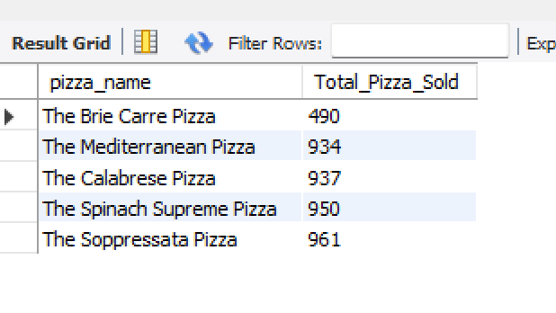

1. **Top 5 Pizzas by Total Orders:**

SELECT pizza_name, COUNT(DISTINCT order_id) AS Total_Orders

FROM pizza_sales

GROUP BY pizza_name

ORDER BY Total_Orders DESC

LIMIT 5;

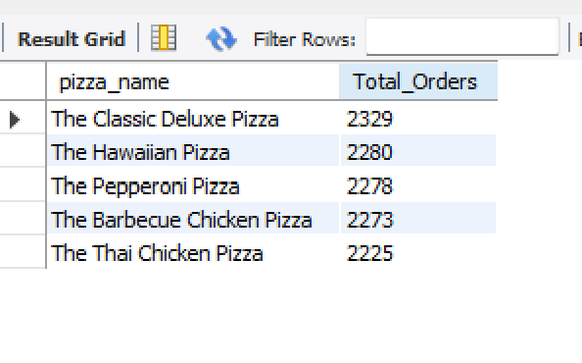

1. **Bottom 5 Pizzas by Total Orders:**

SELECT pizza_name, COUNT(DISTINCT order_id) AS Total_Orders

FROM pizza_sales

GROUP BY pizza_name

ORDER BY Total_Orders ASC

LIMIT 5;

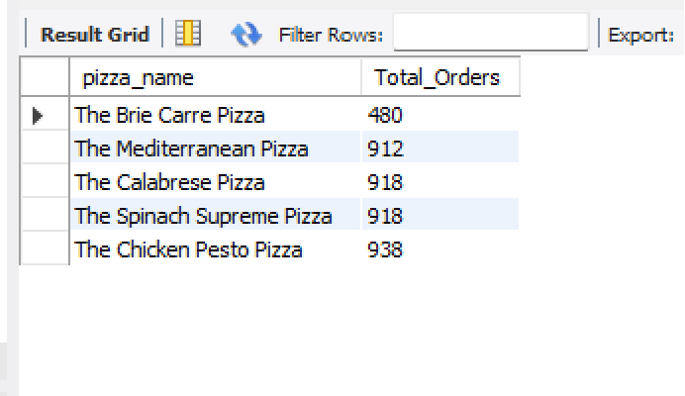

**Note:**

If you want to apply the pizza_category or pizza_size filters to the above queries you can use WHERE clause. Follow some of below examples

SELECT pizza_name, COUNT(DISTINCT order_id) AS Total_Orders

FROM pizza_sales

WHERE pizza_category= ’classic’

GROUP BY pizza_name

ORDER BY Total_Orders ASC

LIMIT 5;